First off, updated the door and gravity inversion trap assets, in the world objects folder 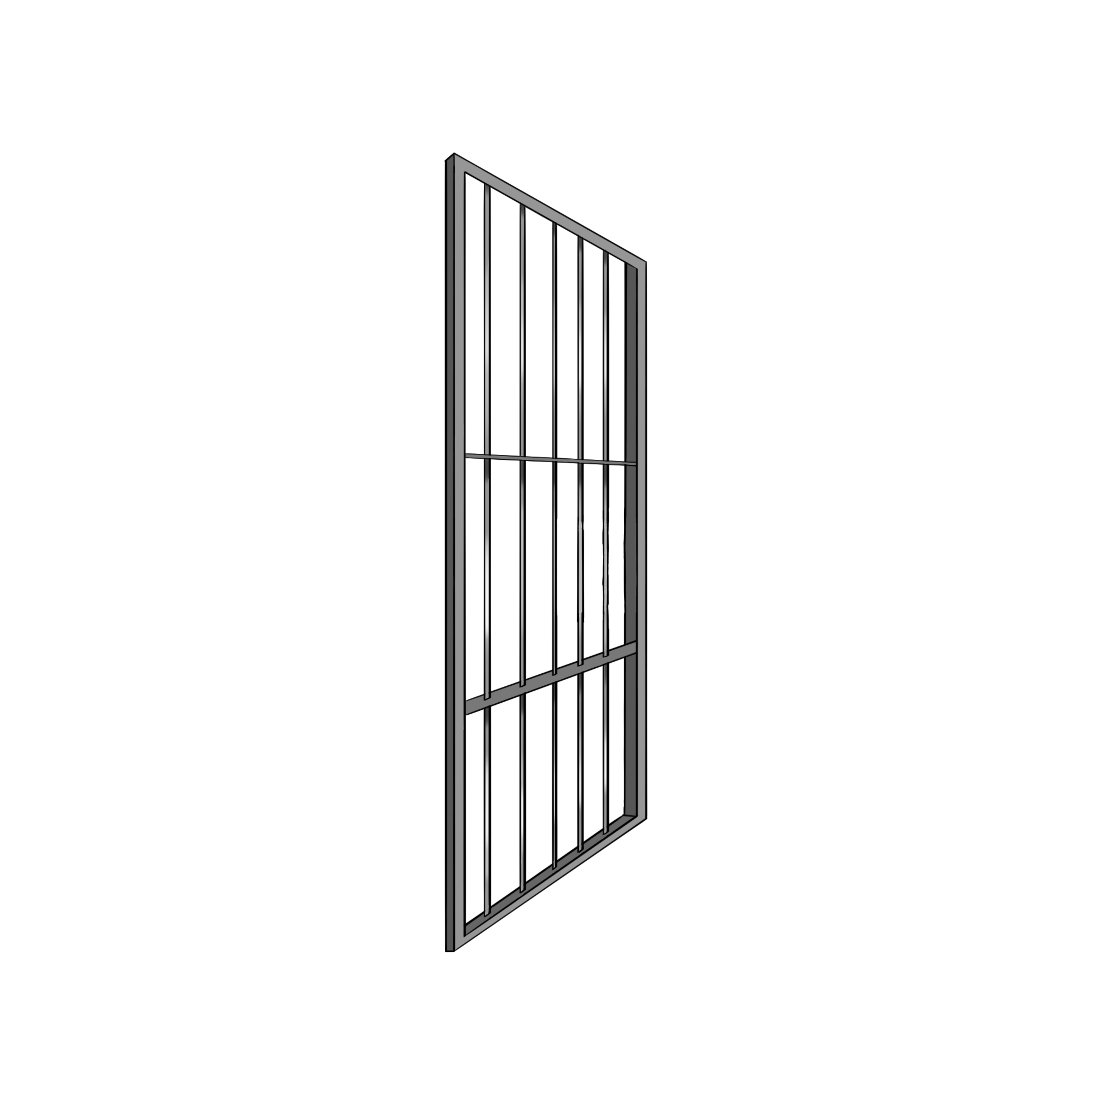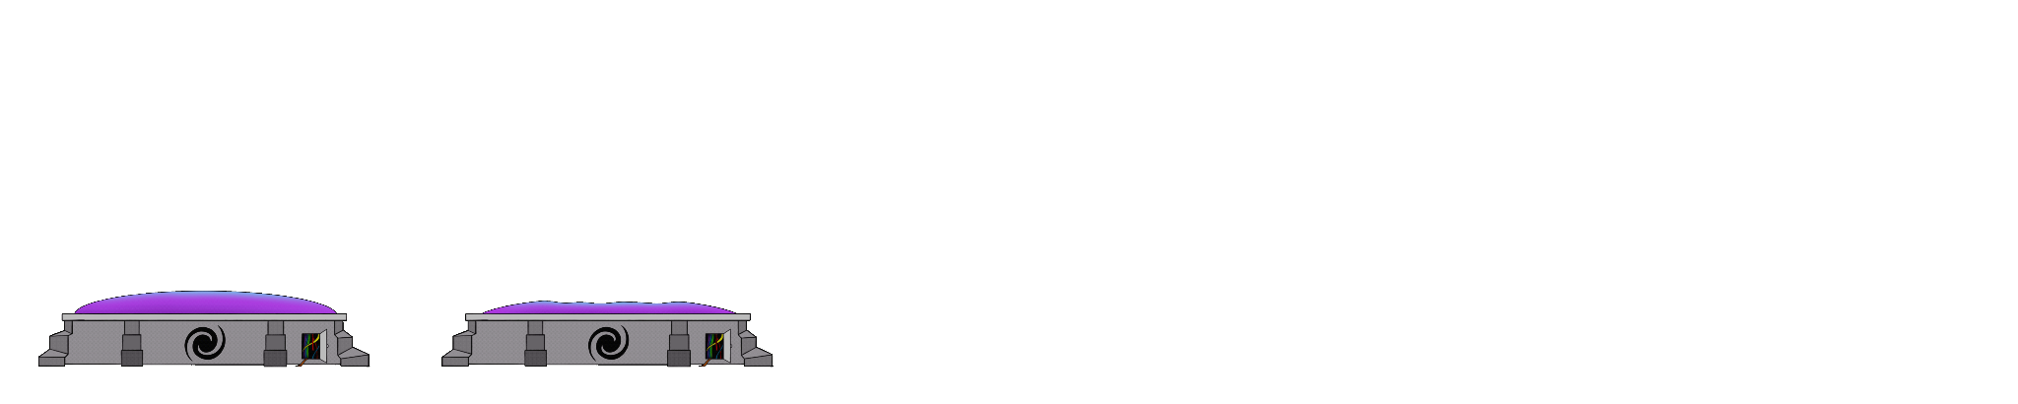

All backgrounds are in the cutscene bg folder, here is the intro:

I did a less dirty/ more dirty versions, and added the character reference for fun just to see them in there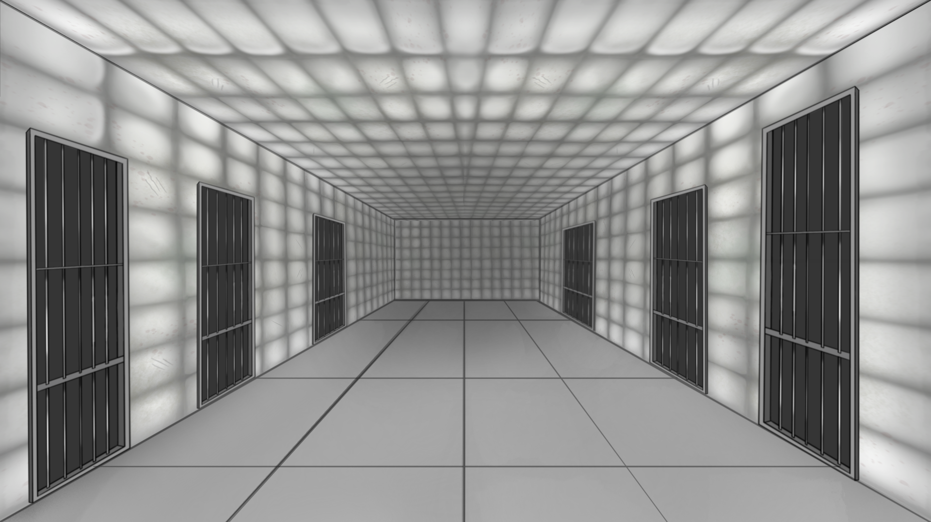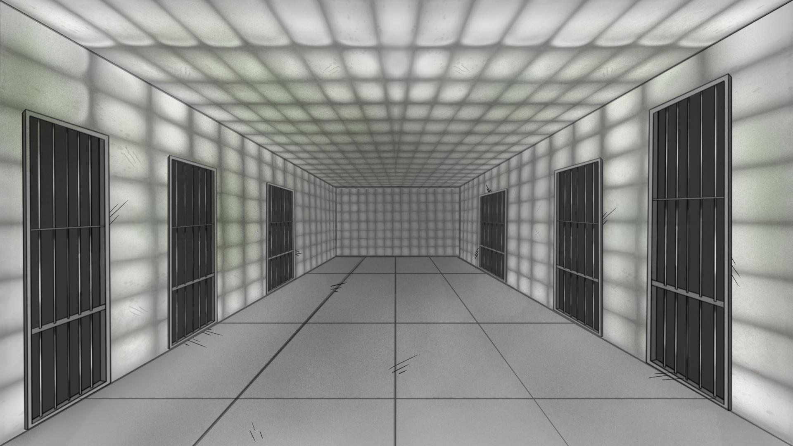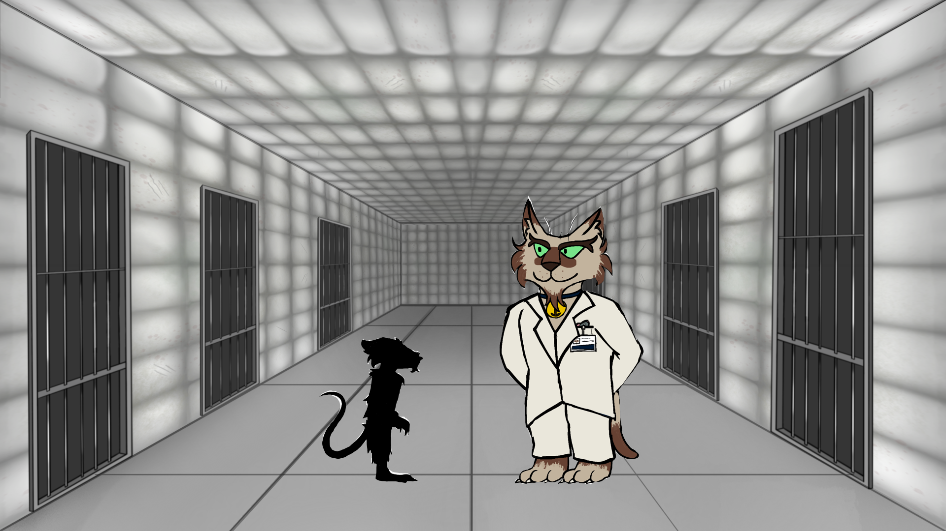

For ending 1, i did the same with a less dirty (left) and more dirty/dark look (right), and added my hand reference in, same with ending 2

Ending 2:

